**CSA1086 - Software Engineering**

**Creating Image and Container in docker**

STEP 1: Open your docker in the background at all times

STEP 2: Create a folder named Docker and place a python file named “first.py” in the folder with some simple code

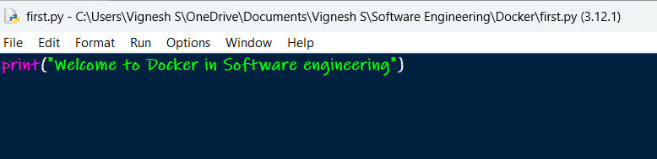

STEP 3: Create a txt file named “Dockerfile.txt” in the Docker folder and enter the given text

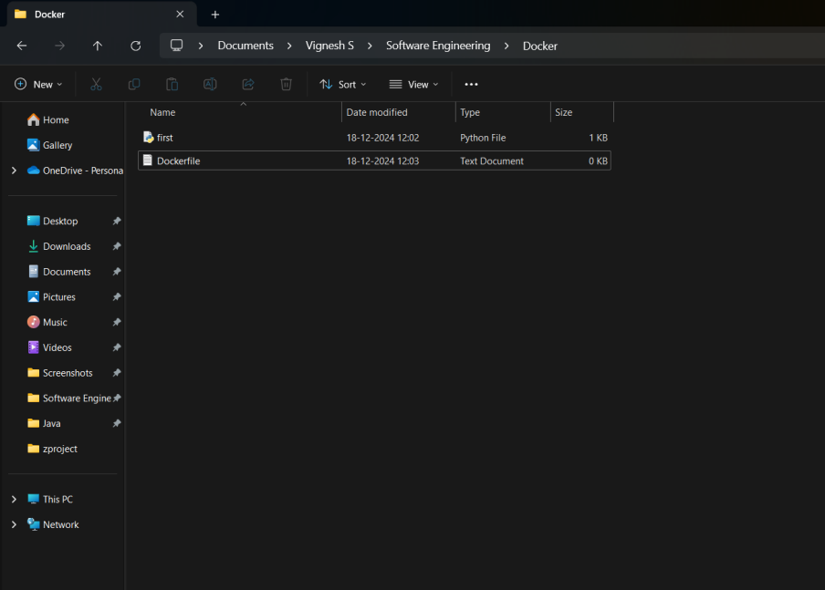

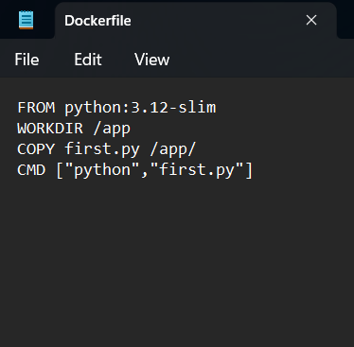

STEP 4: Open terminal in the folder and type the below code to convert txt into file



STEP 5: Type “Docker build -t python312 .” to integrate docker to terminal (312 is python version 3.12. It may change according to your device)

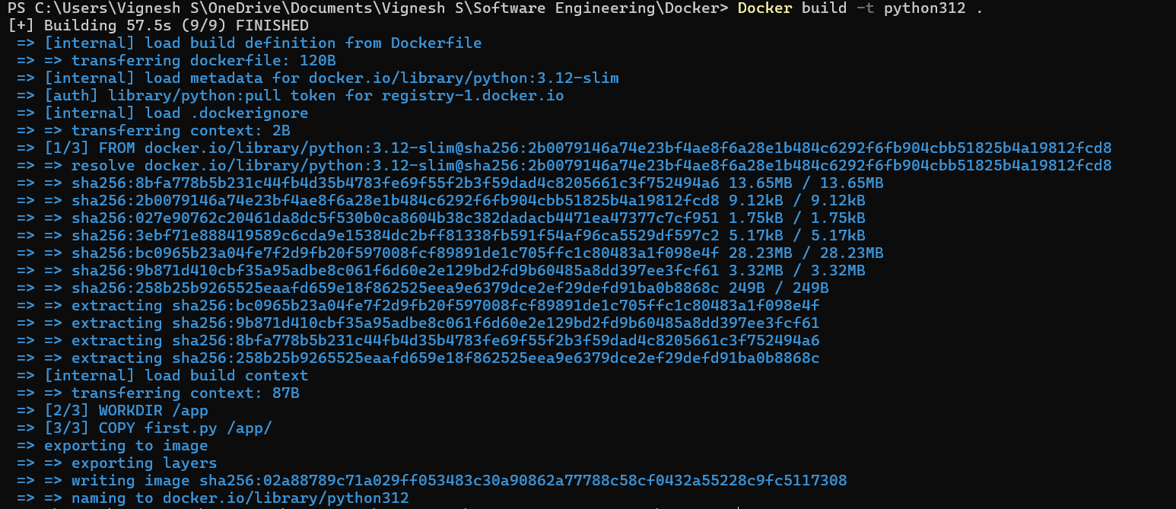

STEP 6: Type “Docker run python312” to print the output of your code



STEP 7: Type “Docker login” to login into your account



STEP 8: Type “Docker tag python312 <username>/python312” to create a container



STEP 9: Type “Docker push <username>/python312” to push the python file as image into the container

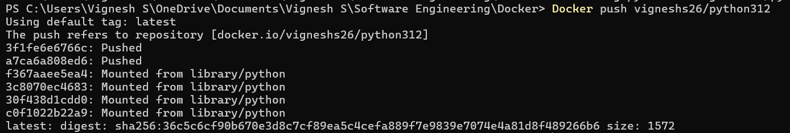

STEP 10: Check your docker for the new container

